Website 2025
PEMF For Holistic Health

Office (949) 600 7899  WhatsApp (949) 891 5572 | 22706 Aspan St, Suite 504  Lake Forest, CA 92630 | Office and Home  Visits Available | Google  Translate

1 | 2 | 3 | 4 | 5 | 6 |  | 7 |  | 8
Home | PEMF | Holistic Health | Qi Energy | Sleep | Mental Health  - Stress  - Relaxation | Sports |  | Animals
9 |  | 10
Product |  | Contact

Home Page

PEMF

Pulsed Electro Magnetic Field



PEMF - Holistic Approach to Health and Wellness

Are you still feeling stressed out? Low energy? Not sleeping well?

Nothing else seems to work anymore

Try adding a holistic approach by laying on the PEMF whole body mat

PEMF - Holistic Approach
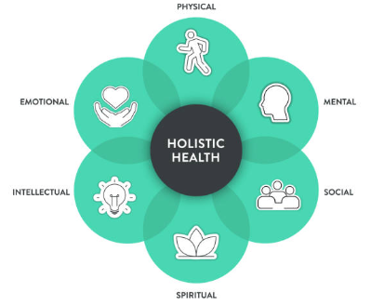 | A holistic approach to health considers and integrates the mental, emotional, physical, intellectual, social, and spiritual aspects of a person, viewing them as interconnected parts of overall well-being  This perspective recognizes that imbalances in one area can affect others. PEMF is a holistic approach to promote a state of total wellness  Holistic health using PEMF, aims to achieve overall well-being by addressing interconnected aspects of life, such as mental health, emotional health, intellectual health, physical health, social health and spiritual health

The PEMF system is not a medical device and is not intended to diagnose. cure. mitigate. prevent or treat any disease

End of Home Page

Page 2 of Website
PEMF for Healthy Lifestyle
Air, food, water, sunshine and Earth’s Magnetic Field Energy are natural essentials for human health
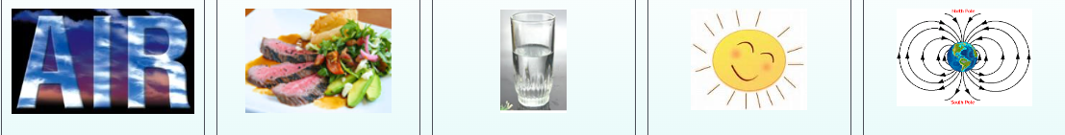

Our Earth’s Magnetic Field  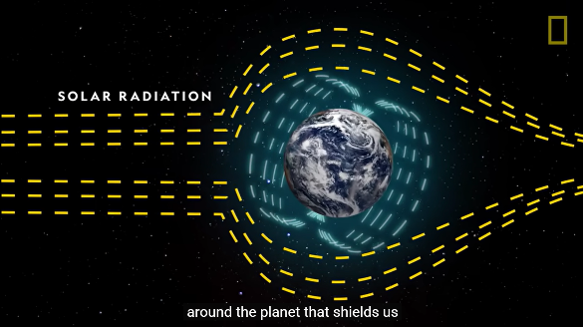  Shields us from radiation  Credit: National Geographic | What is Vital for Health?  In addition to air, food, water and sunshine, our Earth’s natural Magnetic Field energy is also essential for health. But our Earth’s Magnetic Field is weakening and electro-smog is increasing. PEMF mimics Earth’s magnetic field energy for general health and wellness | Magnetic Field Weakening  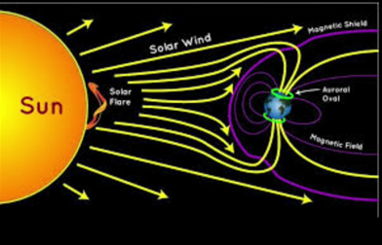  Impacts Life on Earth  Credit: Curious Minds

Importance of Earth’s Magnetic Field

Sources of Radiation  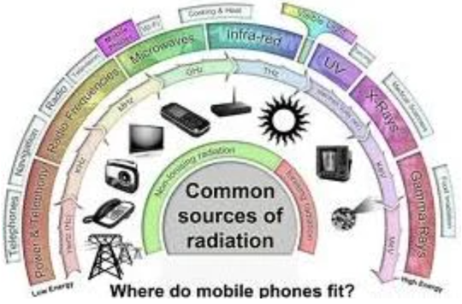 | Protection from Radiation  The Earth's magnetic field is vital for human health because it creates a protective shield (the magnetosphere) to protect the Earth from harmful solar and cosmic radiation. Earth's magnetic field is essential for supporting and protecting life on Earth. Magnetic field is an essential environmental factor for human existence | Principle of Magnet  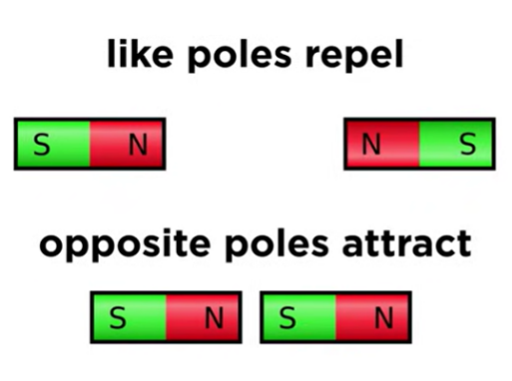

PEMF Mimics Earth’s Magnetic Field Energy
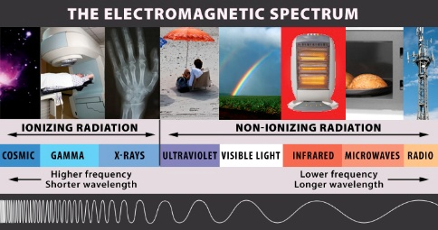 | PEMF Technology for Wellness Use  Electromagnetic force is the fundamental power train of our Earth - an inevitable source of energy and vitality for our sense of wellness! PEMF is the 5th element of health that mimics the earth’s natural magnetic field energy. Utilize the electromagnetic spectrum, retain our overall well-being with the most advanced and comprehensive PEMF technology for wellness use in the world

Website    X | PEMF for Holistic Health  22706 Aspan St, Suite 504,  Lake Forest, CA 92630 | Call / Text / WhatsApp  Certified PEMF Expert Sharon  for Appointment (949) 600 7899 | WeChat ID  

Disclaimer: This information is intended for educational purposes only and should not be taken as medical advice. Always consult with a qualified professional before making any decisions related to your health or wellness plan
End of Page 2 on PEMF

Page 3
PEMF for Holistic Health
Holistic health is a wellness approach that considers a person's physical, intellectual, mental, emotional, social, and spiritual well-being, recognizing these interconnected aspects as essential for optimal health and balance | 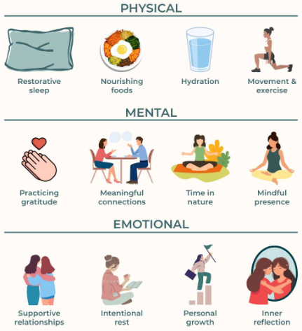 | Holistic health is a whole-person approach that emphasizes optimum body and mind health and aims to empower you by integrating natural, conventional, healthy lifestyle-based practices like PEMF to achieve overall health and wellness

PEMF for Wellness
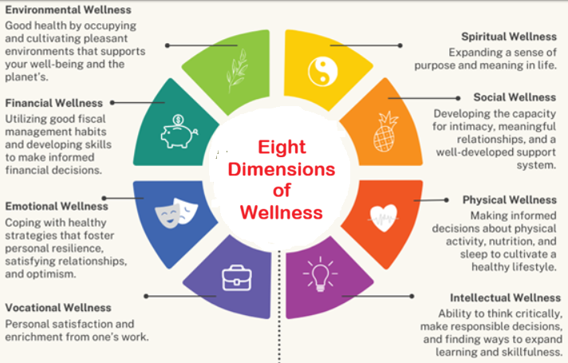

Website  X | PEMF for Holistic Health  22706 Aspan St, Suite 504,  Lake Forest, CA 92630 | Call / Text / WhatsApp  Certified PEMF Expert Sharon  for Appointment (949) 600 7899 | WeChat ID
Disclaimer: This information is intended for educational purposes only and should not be taken as medical advice. Always consult with a qualified professional before making any decisions related to your health or wellness plan
End of Page 3

Page4
PEMF Enhances Qi Energy

Increased Alertness and Focus You feel more awake, sharp, and focused on the task at hand  Greater Motivation and Productivity  You are more inclined to start and complete tasks, feeling prepared to tackle anything  Improved Mood and Enthusiasm  High energy levels often correlate with feeling enthusiastic, fun-loving, and sociable | Benefits of Being Energetic  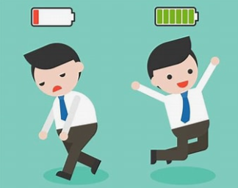  Try this holistic approach using PEMF system to enhance your Qi energy, stamina, and power and you will feel the difference | Physical Vitality  You feel vibrant and ready to move your body, have more stamina and more power in performance, rather than  feeling tired, low energy despite being well rested  Willingness to Try New Experiences  A higher energy state can make you more comfortable and eager to explore new people, places, and experiences

Website | PEMF for Holistic Health  22706 Aspan St, Suite 504,  Lake Forest, CA 92630 | Call / Text / WhatsApp  Certified PEMF Expert Sharon  for Appointment (949) 600 7899 | WeChat ID
Disclaimer: This information is intended for educational purposes only and should not be taken as medical advice. Always consult with a qualified professional before making any decisions related to your health or wellness plan
End of Page 4
Page 5

PEMF Promotes Good Sleep

PEMF is an effective tool for improving sleep quality. PEMF is a non-invasive, non-addictive, drug-free approach for promoting better sleep. Sleep allows your body and mind to recharge, leaving you refreshed and alert when you wake up | 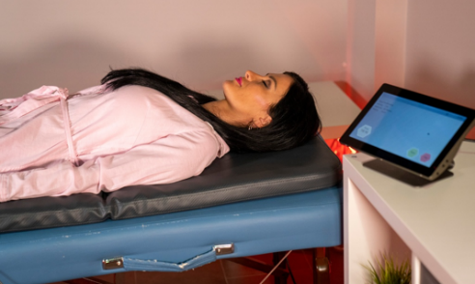 | PEMF helps you to relax and unwind and put your mind at rest. Fall asleep faster and have better quality and quantity of sleep. Wake up less often during the night. Deep sleep is crucial for physical and mental rejuvenation

Website | PEMF for Holistic Health  22706 Aspan St, Suite 504,  Lake Forest, CA 92630 | Call / Text / WhatsApp  Certified PEMF Expert Sharon  for Appointment (949) 600 7899 | WeChat ID
Disclaimer: This information is intended for educational purposes only and should not be taken as medical advice. Always consult with a qualified professional before making any decisions related to your health or wellness plan
End of Page 5

Page 6
PEMF Improves Mental Acuity

Mental Acuity  Mental acuity refers to your cognitive health, which includes clarity, focus, quick thinking, problem-solving, and memory  Emotional Health  Emotional health pertains to your awareness of, understanding of, and ability to manage your feelings and moods  Spiritual Health  Focuses on having a sense of purpose, values, and beliefs that give life meaning  Social Health  Involves your ability to build and maintain healthy relationships and interact effectively with others  Financial Health  The ability to manage your finances effectively and achieve financial security | Brainwave Entrainment  Brain health is a vital component of overall well-being and contributes to a person's ability to make informed decisions, cope with stress, and achieve your goals. Brainwave Entrainment is a holistic experience for the brain, also known as Spa for the Mind, reduces stress, resulting in relaxation, calm and ease    Intelligent Magnetic Resonance Stimulation prime PEMF and Brainwave Entrainment are a safe, non-invasive and non-addictive, affordable application to improve mental acuity and learning ability thus promoting brain health and wellness | Intellectual Health  Intellectual Health refers to the state of well-being in which an individual can:  Engage in critical thinking  Analyze information, form opinions and solve problems  Curiosity and lifelong learning  Maintain an open mind, seek new knowledge, and explore different perspectives  Creativity  Generate original ideas, express oneself, and engage in stimulating activities  Self-awareness  Understand one's own cognitive strengths and weaknesses and work to improve them  Adaptability  Adjust new information and situations and embrace intellectual challenges

Page 6
1 st Link under Mental Health
PEMF Helps Manage Stress

What is Stress?  Stress is a physiological and psychological response to perceived or real challenges or threats. It is a natural and adaptive mechanism that helps individuals cope with demanding situations | 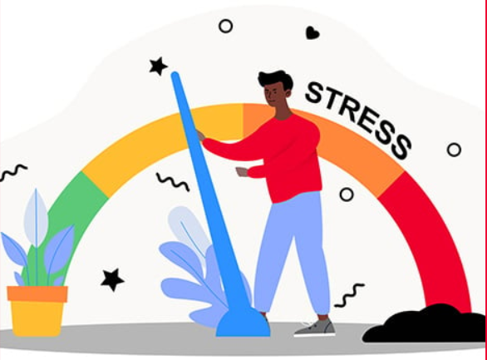 | Healthy Coping Mechanism  Choose a holistic approach using PEMF as your healthy coping mechanism. PEMF is safe, effective, non-invasive and non-addictive tool. You can use it anytime in the comfort of your own home or office
Page 6
2ND Link under Mental Health
PEMF for Relaxation

What is Relaxation?  Relaxation is the state of being calm, comfortable, and free from stress. Relaxation helps improve coping with stress, leading to a state of peace and tranquility |  | PEMF can be effective for relaxation within minutes in the comfort of your own home or office. PEMF aids your body in returning to a calm and balanced state

Benefits of Relaxation

Physical Health  Relaxation enhances sleep quality by reducing stress and calming the mind, helps to wind down the body and prepare for sleep, leading to better sleep onset, better quality and quantity of sleep and improved rejuvenation | Mental Health  Improving mood and coping mechanisms. Enhances cognitive function, memory and concentration. Promotes clearer thinking and problem-solving abilities. Increases self-awareness and emotional regulation | Emotional Health  Provides a sense of calm and peace, reducing stress and improves resilience to adversity and promotes emotional well-being. Enhances feelings of happiness, contentment, fulfillment and healthier relationships

Website  X | PEMF for Holistic Health  22706 Aspan St, Suite 504,  Lake Forest, CA 92630 | Call / Text / WhatsApp  Certified PEMF Expert Sharon  for Appointment (949) 600 7899 | WeChat ID
Disclaimer: This information is intended for educational purposes only and should not be taken as medical advice. Always consult with a qualified professional before making any decisions related to your health or wellness plan

Page 7
Sports
PEMF Enhances Athletic Performance

IMRS prime PEMF, within the scope of elite and mass sports, is an effective tool to promote holistic wellness for performance and endurance enhancement for those who work out or are in training | 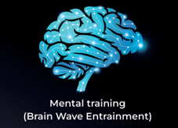 | PEMF with Brain Wave Entrainment enhances visualization and mindfulness to build mental resilience, improve focus, enhance thinking process and reaction times, better sleep and management of stress

Passive Warm-Up  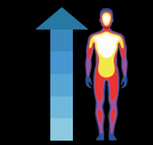  It is faster and more effective to combine active warm-up and passive warm-up with PEMF as both can offer a more comprehensive approach | Rejuvenation    The IMRS Prime accelerates rejuvenation after physical activity, thus allowing you to train harder, perform better and compete more often | Enhanced Performance    IMRS Prime PEMF is a safe, efficient and comprehensive holistic approach towards enhanced performance and endurance

Website  x | PEMF for Holistic Health  22706 Aspan St, Suite 504,  Lake Forest, CA 92630 | Call / Text / WhatsApp  Certified PEMF Expert Sharon  for Appointment (949) 600 7899 | WeChat ID
Disclaimer: This information is intended for educational purposes only and should not be taken as medical advice. Always consult with a qualified professional before making any decisions related to your health or wellness plan

Page 8
PEMF for Animals

PEMF for Pets    Pets love to be on the PEMF mat for relaxation, and they always look forward to the next session | How Animals Perceive PEMF  IMRS Fauna PEMF for animals is a non-invasive tool, and it has been shown to promote well-being in various animal species at home or in the zoos and sanctuaries. Many animals often experience PEMF as soothing. promoting a sense of calm | Stress Free PEMF Technique    Many animals seem to tolerate stress free PEMF technique  and benefit from PEMF

and use cool-downs to help the horse's body recover.
PEMF for Racehorses

Stress Free Body Applicator    Conditioning  Always implement proper warm-up routines for horses before exercise to prepare the horses for work. | PEMF Improves Performance    Stamina  Workload and intensity should be increased gradually to allow the horses to adapt and strengthen over time. | Stress Free Leg Applicator  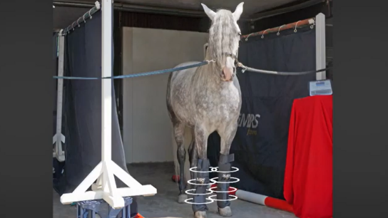  Training  Avoid repetitive strain. Keep the horses mentally stimulated with variety of activities. Ensure sufficient rest periods

Page 9- Product Page
Intelligent Magnetic Resonance Stimulation PEMF


Learn More
Text l Call l WhatsApp
(949) 600 7899

Page 10

Full Size PEMF Wellness System on the Go


Learn More
Text l Call l WhatsApp
(949) 600 7899

Page 11
Swiss Bionic Solutions

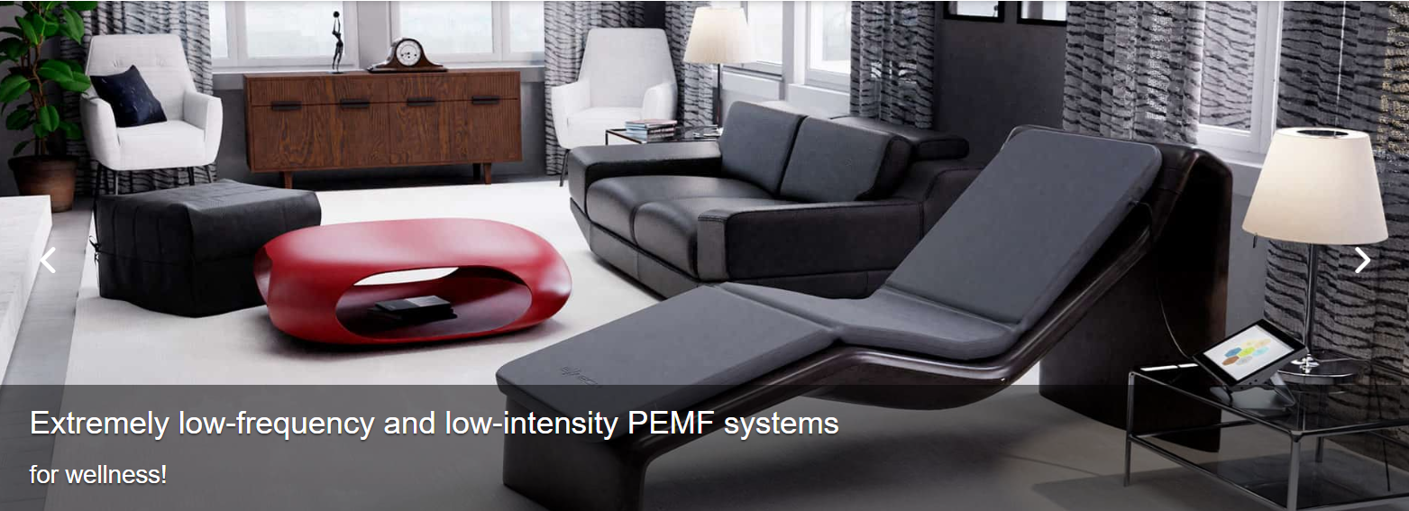
Learn More
Text l Call l WhatsApp
(949) 600 7899

Website | PEMF for Holistic Health  22706 Aspan St, Suite 504,  Lake Forest, CA 92630 | Call / Text / WhatsApp  Certified PEMF Expert Sharon  for Appointment (949) 600 7899 | WeChat ID
Disclaimer: This information is intended for educational purposes only and should not be taken as medical advice. Always consult with a qualified professional before making any decisions related to your health or wellness plan

Page 10 – Contact

Your Contact Person:  Sharon Wong | PEMF Consultant  Identification # 81003 | Phone Number:  (949) 600 7899

Send an email to SharonWong168@gmail.com
Your Name: | City/Town: | Country:
Zip/Postal Code: | Reason for Visit

Your Name
Your Address
Your Phone Number
Your Email Address

Your Message

By submitting this form, you confirm that all your information is correct.

The End

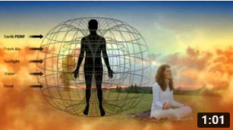  What is PEMF?  Video Credit: Bryant Meyers  https://www.youtube.com/watch?v=WyqVIM6O3II | 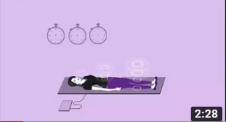  Why Do We Need PEMF?  Video Credit: Swiss Bionic Solutions.  https://www.youtube.com/watch?v=Et8VJ3psSF8 | 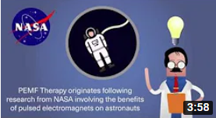  How PEMF Aids in Healing?  Video Credit: NewMed Ltd.  https://www.youtube.com/watch?v=YnXMzf8iwJg&t=14s

FDA Approved PEMF

In 1979 for  Bone Growth | In 1991 for  Post-Op Pain | In 1998 for  Urinary Incontinence | In 2004 for  Risk of Non Cervical Fusion | In 2006 for  Depression | In 2011 for  Brain Cancer

  Dr. Oz & Pain Specialist,  Dr. Dillard Talk on PEMF  Video Credit: Dr. Oz  https://www.youtube.com/watch?v=2_O_3D4P4Bg |   In 2014 Health Canada  approved iMRS PEMF for  • Increase Blood Circulation  • Relieves Aches and Pains. |   PEMF - Live Blood Analysis  Live Long and Stronger  by Dr. Phil McAllister  https://www.youtube.com/watch?v=QNIAqW3aYZQ&t=10s

1 Home Page 1st Link Sports

  Hematoma, Muscle Damage  Video Credit: Dr. Derek  https://www.youtube.com/watch?v=GaN2QOoEk9Y |   Pro Athletes Use PEMF Therapy  Dr. Fidler with Prof. Scheinowitz  Video Credit: MDcurebyaerotel  https://www.youtube.com/watch?v=JVID3zryINk |   PEMF Therapy in Sports by NewMed  Video Credit: NewMed  https://www.youtube.com/watch?v=21WhFbIpYHc&t=6s

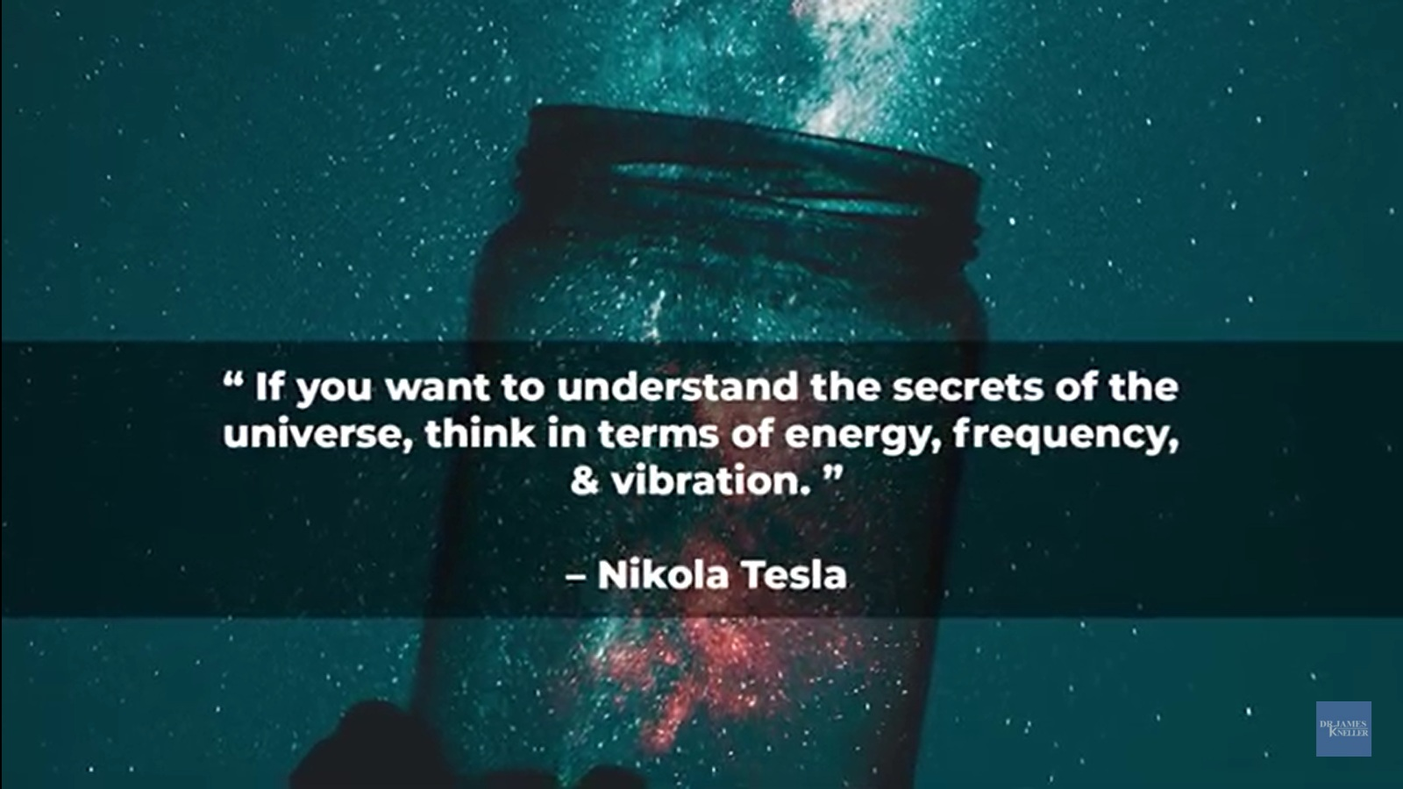
https://youtu.be/jVBQzhU9Aik

What is good health?
- What is health?
- Types
- Factors for good health
- Preserving health
- Summary
The word health refers to a state of complete emotional, mental, and physical well-being. People may be able to maintain or improve their health by eating a balanced diet, exercising regularly, and connecting with others.
Healthcare exists to help people maintain or improve their mental, emotional, and physical well-being. Good health is central to handling stress and living a longer, more active life.
What is health?: Defining and preserving good health

health referred to the ability to maintain homeostasis and recover from insults. Mental, intellectual, emotional, and social health referred to a person’s ability to handle stress, to acquire skills, to maintain relationships, all of which form resources for resiliency and independent living.
The provided text defines health in two ways:
- Physical Health: Refers to the ability to maintain homeostasis and recover from insults.
- Mental, Intellectual, Emotional, and Social Health: Refers to a person's ability to handle stress, acquire skills, and maintain relationships, which are all resources for resiliency and independent living.

health referred to the ability to maintain homeostasis and recover from insults. Mental, intellectual, emotional, and social health referred to a person’s ability to handle stress, to acquire skills, to maintain relationships, all of which form resources for resilience and independent living.

Maintain or improve your health by eating a balanced diet, exercising regularly, and connecting with others and Mother Nature. PEMF system may help you maintain or improve your mental, emotional, and physical well-being.

https://theworldbook.org/types-of-health/

Buyers_Guide_en (3).pdf

Summary: Low-pulsed PEMF systems utilize carrier frequencies within the natural range (0.1-30 Hz). This ensures a high potential of resonance and with it a much more effective reaction of the targeted area. At the same time, low-frequencies do not create a noticeable thermal effect, the exposed tissue will not get warm or even hot. The most efficient PEMF systems for home use are within this described “natural frequency range”

Summary: PEMF devices with sine wave frequency generators are not only outdated and cheap to manufacture, but also ineffective in creating the desired resonance effect. Applying only one frequency at a time with slow rise and fall times, inhibits and/or delays resonance with most cells in the body. Square waves are scientifically proven to be very effective for local, targeted applications. Modern PEMF devices offer square wave signals to treat isolated body parts. As of today, the most valuable saw tooth patterns are only used by very few manufacturers. The saw tooth wave is regarded as the gold standard for whole body applications. Its signal is ideal to make use of upper harmonics within the even and uneven range, resulting in the highest resonance effect on the body. Recently only two systems in the world are capable of producing the extremely complex triple sawtooth pattern, which progressively increases the desired resonance effect

Fatigued
Why am I so Tired? | Tired all the Time? | What Can I Do About It?

1
PEMF devices do not treat a specific condition.
Instead, they optimize your body’s natural self-healing and self-regulating functions of all your cells, tissues, and organs

What Will Happen When Earth's North And South Pole Flip?
https://youtu.be/I6Ggs7nUjxA

